Unit 9 What does he look like?
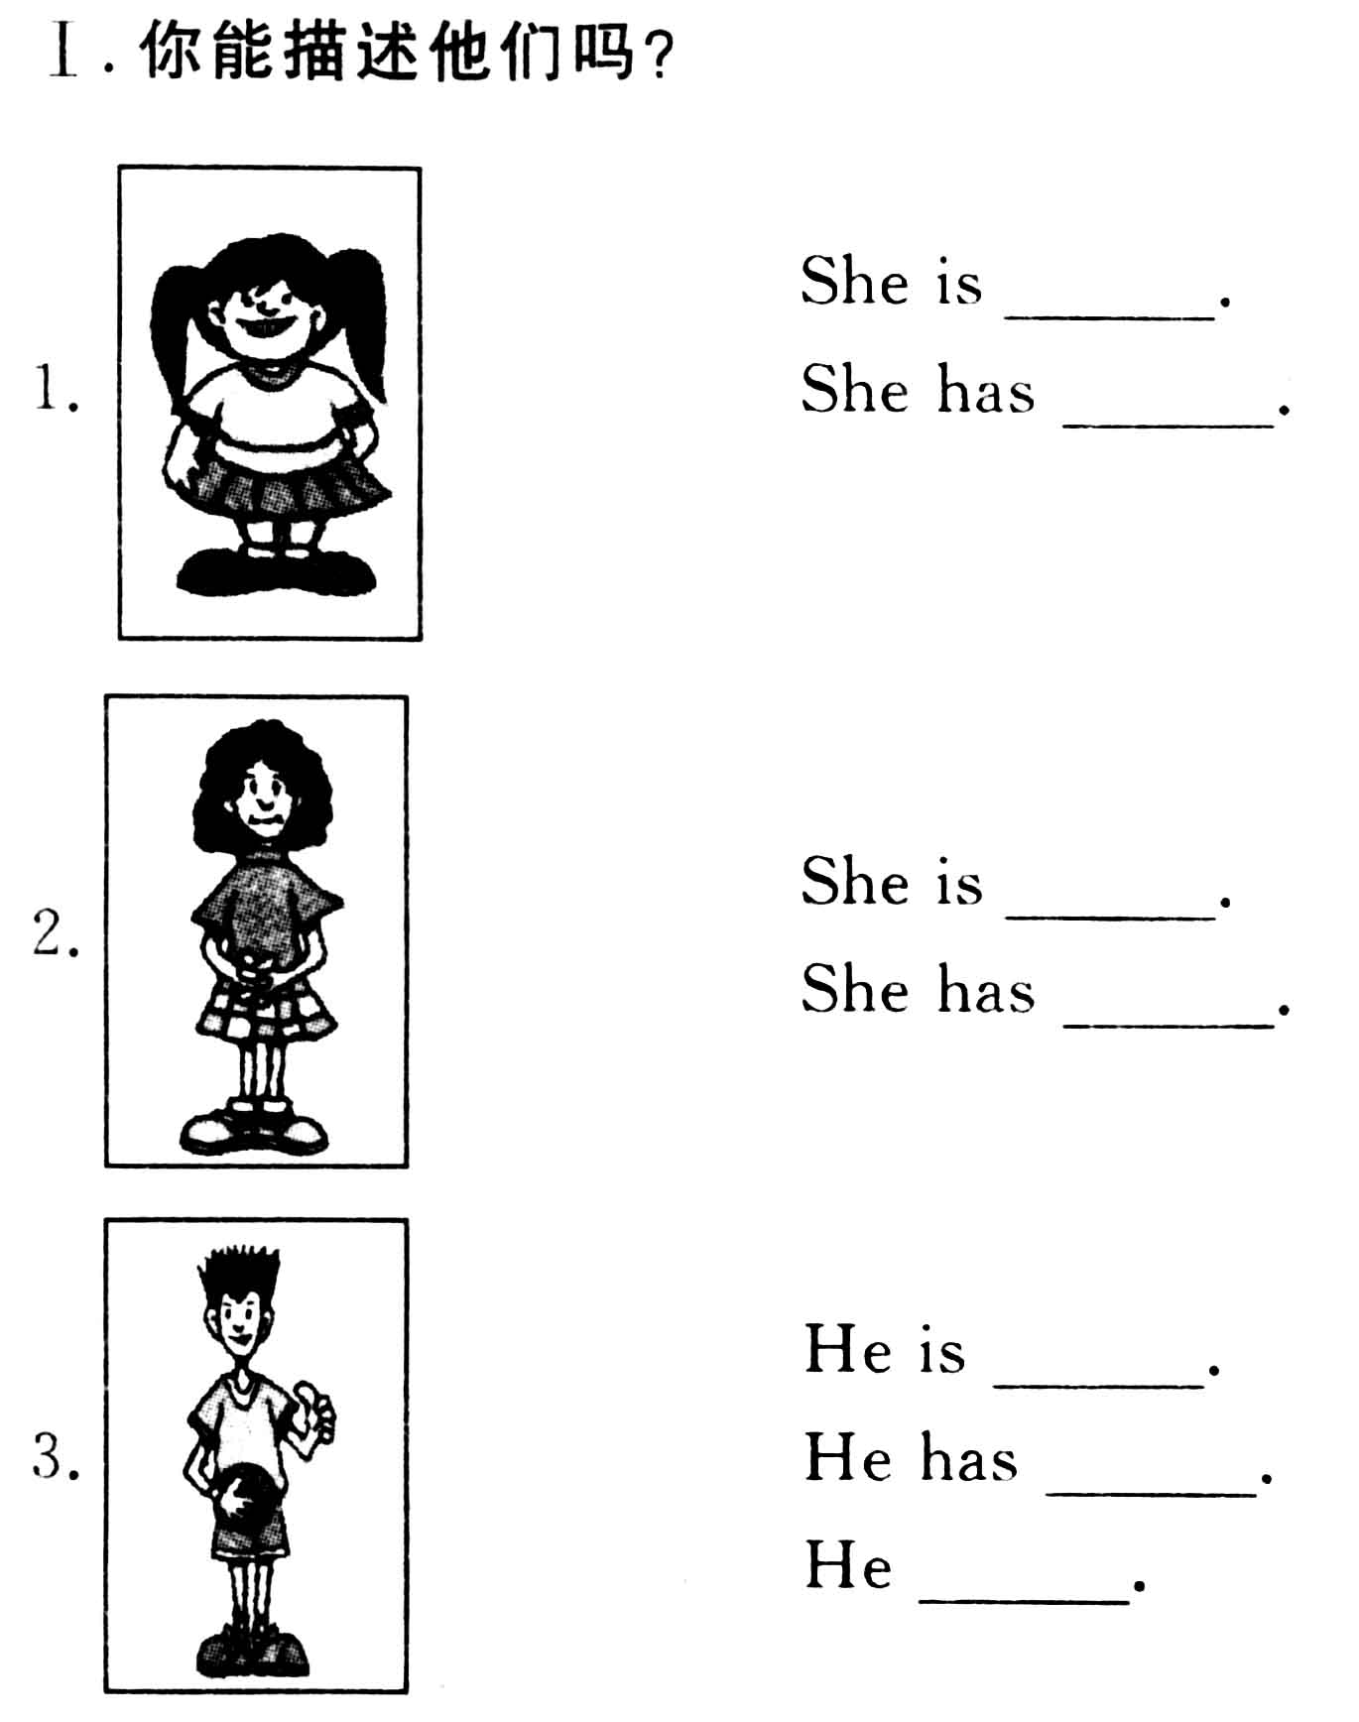
Ⅱ.看信息完成对话
A:Look!This is my good friend.
B: ?
A:His name is Wilson.
B: ?
A:He’s 30 years old.
B: ?
A:He is from Japan.
B:What does he like?
A:He .
B:What does he look like?
A:He .
Name Mr Wilson
Age 30
Nationality Japanese
Likes Reading,Classical music
Job Manager
Appearance Medium weight straight hair
Personality Outgoing
Ⅲ.请你描述一下你的家人
My grandfather is .
My mother is .
My father is .
My cousin is .
附参考答案：
Ⅰ.1.short and a little bit heavy;long,black hair
2.thin and medium height;short,curly hair
3.tall;short,straight hair;likes basketball
Ⅱ.B.What’s his name
B.How old is he
B.Where is he from
A.He likes reading and classical music
A.He has medium weight and staight hair
He is outgoing
Ⅲ.略

